[Date]

**Afaf Abdelwhab Abdelkader**

***Programming Languages***

**Name:** Afaf Abdelwhab Abdelkader

**B.N:** 517

**Topic:** programming languages

**Date**: 2020 / 6 / 3

**The Aim of This Project:**

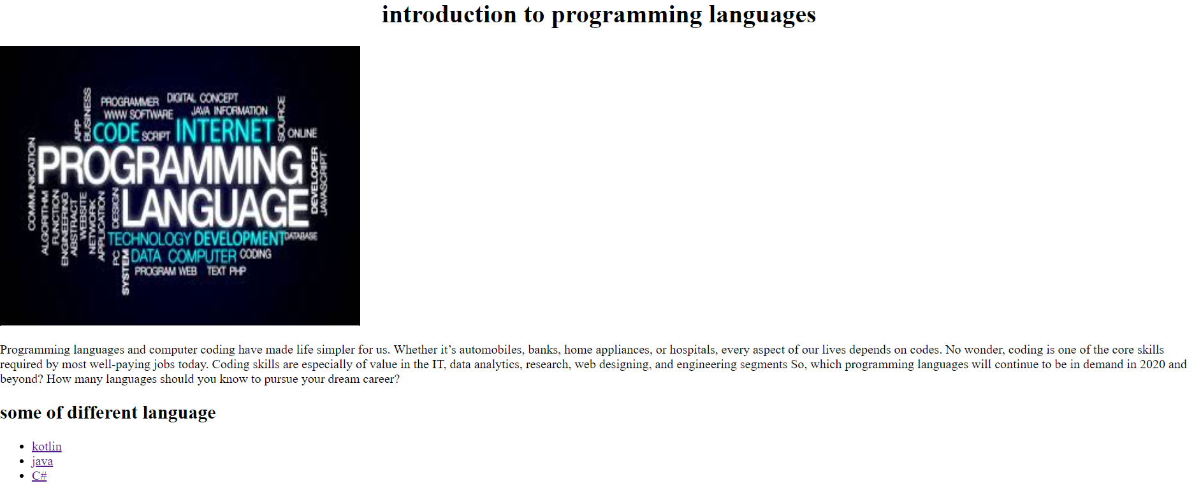Clarify information about some programming languages ​​that are of great importance in the world of technology such as c#, kotlin and Java. This project consists of four web page .the first page contain about the importance of learning programming and has 3 links of three languages. It also has a table to clarify the history of them.

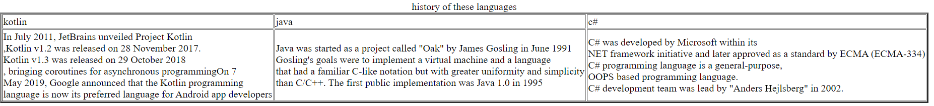

**This photo to show the source code**

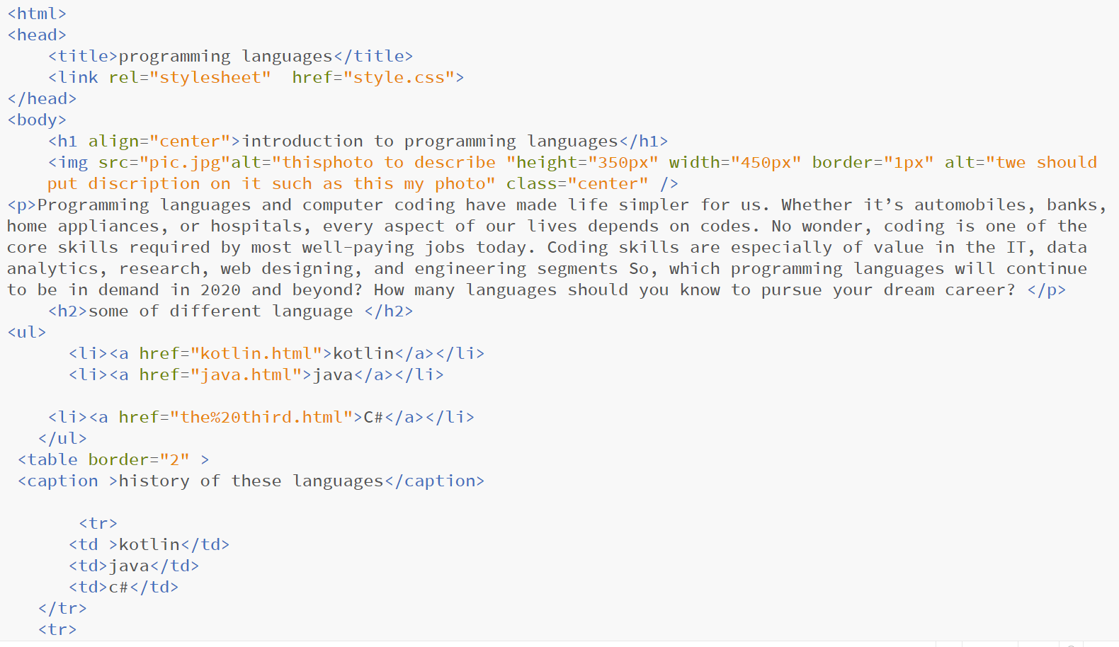

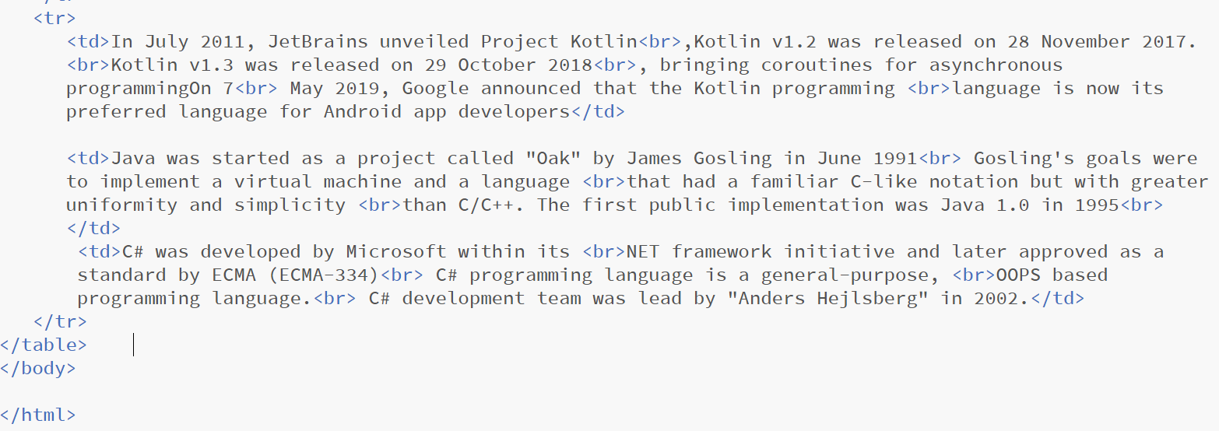

When you enter on the first link you will show this :

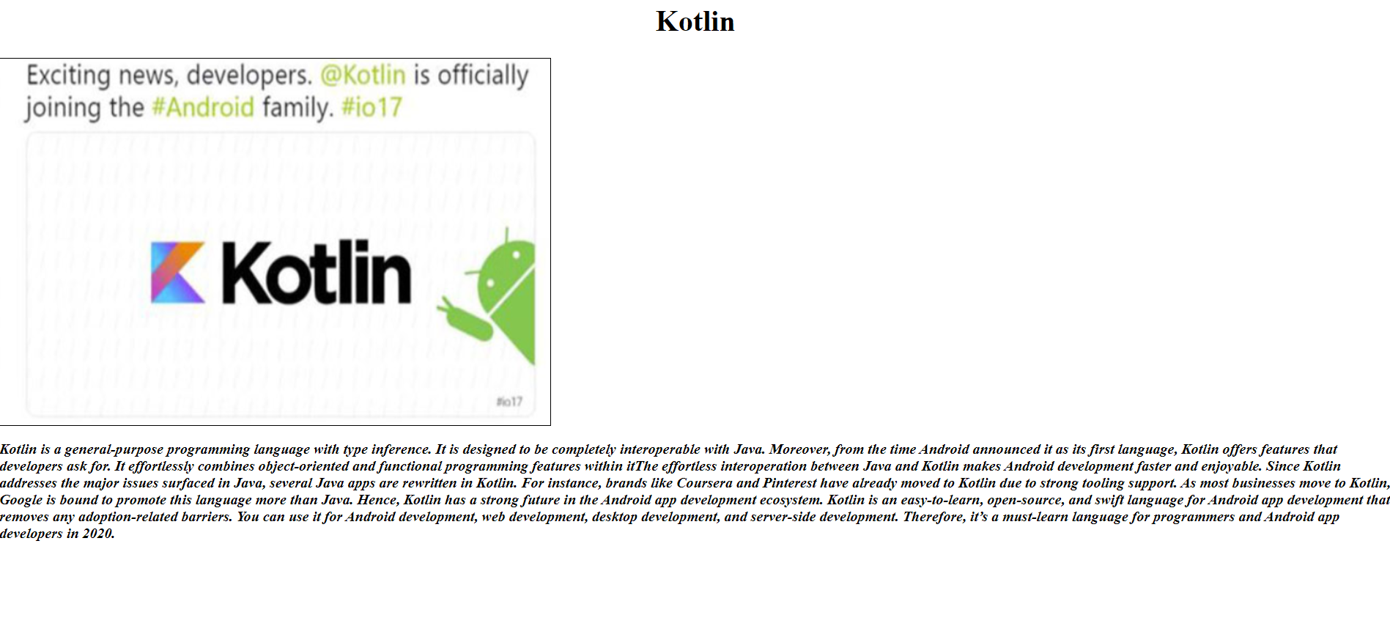

The code of this page is:

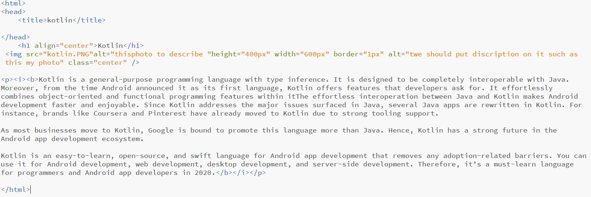

The second link :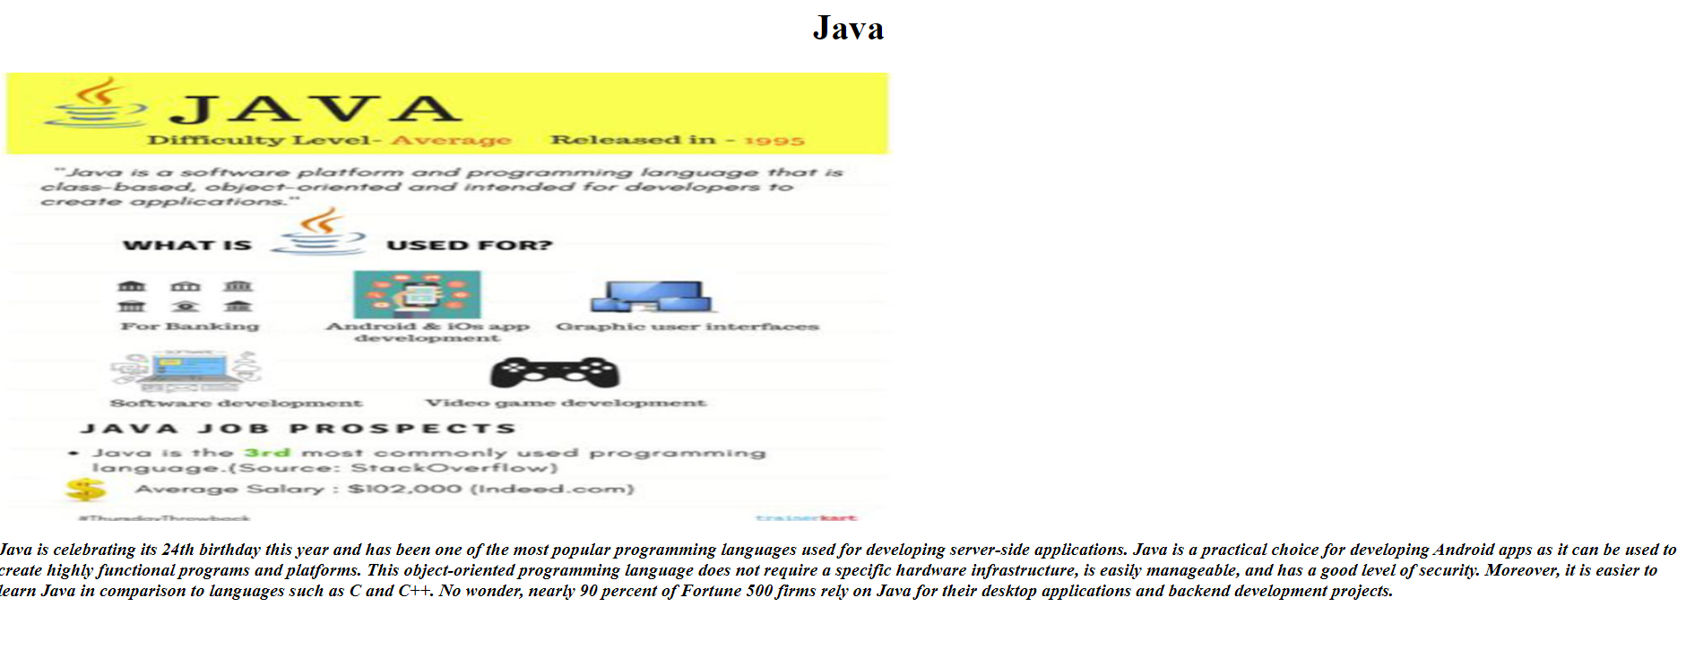

The code of this page is :

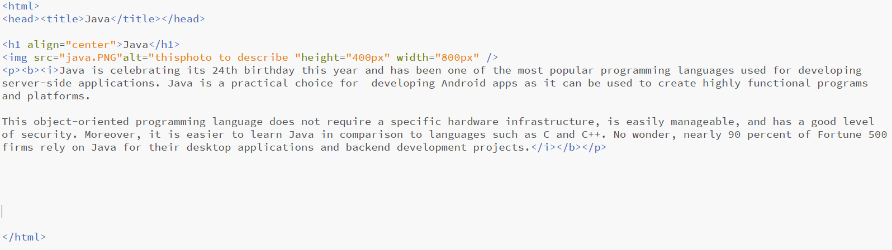

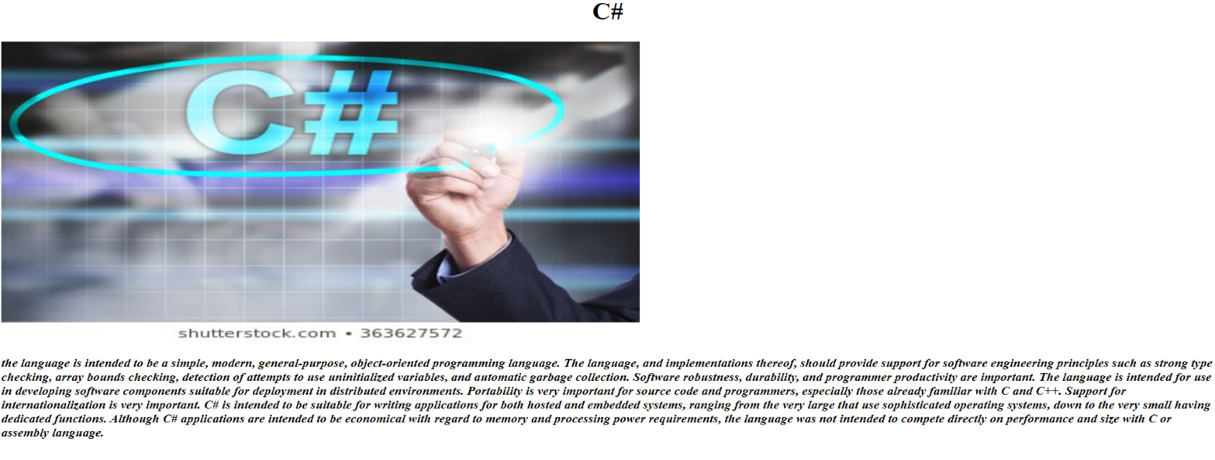 **The third phot is:**

The code of this page is:

